**Detection and Analysis of Stargardt's Disease**

Project report submitted for

**4th Semester Minor Project-2**

**in**

**Department of DSAI**

By,

**Pediredla Suman(221020444)**

**Bonda Naveen Kumar(221020420)**

**Sambangi Chaitanya(221000049)**

**

**Department of DSAI**

**Dr. Shyama Prasad Mukherjee**

**International Institute of Information Technology, Naya Raipur**

**(A Joint Initiative of Govt. of Chhattisgarh and NTPC)**

**Email:** [**iiitnr@iiitnr.ac.in**](mailto:iiitnr@iiitnr.ac.in)**, Tel: (0771) 2474040, Web:** [**www.iiitnr.ac.in**](http://www.iiitnr.ac.in)

**Guidelines for Annexure -I**

**CERTIFICATE**

This is to certify that the project titled “**Detection and Analysis of Stargardt's Disease**” by “**Pediredla Suman(221020444) ,Bonda**

**Naveen Kumar(221020420) , Sambangi Chaitanya(221000049)**” has been carried out under my/our supervision and that this work has not been submitted elsewhere for a degree.

(Signature of Guide)

___________________________________________

**Dr. Rajesh Ingle**

**Professor, Dean Academics, & HOD CSE**

**Department of CSE**

**Dr. SPM IIIT-NR**

**May, 2024**

**Declaration**

I declare that this written submission represents my ideas in my own words and where others' ideas or words have been included, I have adequately cited and referenced the original sources. I also declare that I have adhered to all principles of academic honesty and integrity and have not misrepresented or fabricated or falsified any idea/data/fact/source in my submission. I understand that any violation of the above will be cause for disciplinary action by the Institute and can also evoke penal action from the sources which have thus not been properly cited or from whom proper permission has not been taken when needed.

**_________________**

**Pediredla Suman**

**221020444**

**_________________**

**Bonda Naveen Kumar**

**221020420**

**_________________**

**Sambangi Chaitanya**

**221000049**

**Date : 16/05/2024**

**PLAGARISM REPORT**

**(The plagiarism of the minor project report must be less the 10% for final acceptance of the report by panel members)**

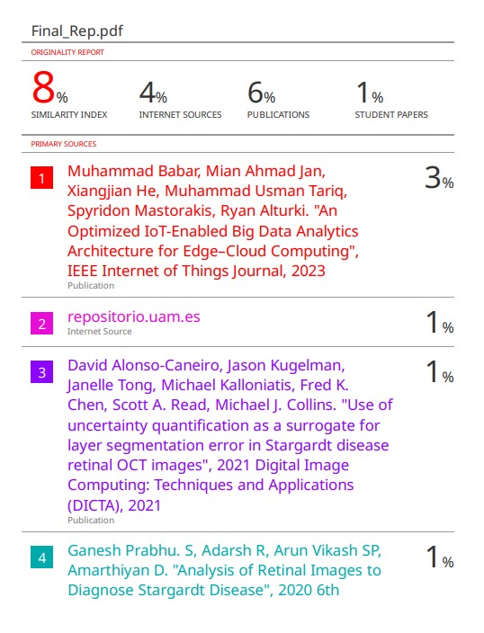

**Approval Sheet**

This project report entitled “**Detection and Analysis of Stargardt's Disease**” by

“**Pediredla Suman(221020444) , Bonda Naveen Kumar(221020420) ,Sambangi Chaitanya(221000049)**” is approved for 4th Semester Minor Project.

________________________

**Dr. Rajesh Ingle**

________________________

**Dr. Satyanarayana Vollala**

________________________

**Dr. Kavita Jaiswal**

**Date:** 16/05/2024 **Place : IIIT Naya Raipur**

**Detection and Analysis of Stargardt's Disease**

Pediredla Suman, *B.Tech 2nd Year* , Bonda Naveen Kumar, B.Tech 2nd Year, and Sambangi Chaitanya, B.Tech 2nd Year

*Abstract*— Stargardt disease, also known as Stargardt macular dystrophy (SMD), is a genetic disease of the retina that occurs mainly in childhood or adolescence. This leads to progressive vision loss due to degeneration of the macula, the central part of the retina that is essential for sharp tissues. The purpose of analyzing disease, to develop therapies and treatments to address problems caused by this genetic disorder and its progression over time. This review examines various diagnostic methods such as Fundus autofluorescence imaging, optical coherence tomography, and their advantages, limitations, and clinical applications. It is also investigating promising technologies such as adaptive optical imaging and artificial intelligence to improve diagnostic accuracy and monitor disease progression. Combining current knowledge and technological advances, this review aims to provide clinicians and researchers with a comprehensive overview of the latest approaches in the detection and analysis of Stargardt disease. Ultimately, this synthesis can facilitate improved patient care and outcomes, driving advancements in the management of this debilitating genetic condition.

*Index Terms*— Fundus autofluorescence imaging, Macular degeneration, Optical coherence tomography, Stargardt disease.

# **INTRODUCTION**

**S**targardt disease, also known as Stargardt macular dystrophy (SMD), is an inherited retinal disease characterized by progressive vision loss that mainly affects children and adolescents[1]. With an onset typically occurring between the ages of 6 and 20, this condition represents a significant burden on affected individuals and their families, given its progressive nature and potential for severe visual impairment[4]. This condition, caused by mutations in the ABCA4 gene, causes degeneration of the macula, the central part of the retina that is crucial for sharp, detailed vision[3]. While clinical presentation can vary, affected individuals commonly experience decreased central vision, difficulties with color discrimination, and impaired dark adaptation.

 As a result, people with Stargardt disease have reduced central vision, color perception & contrast sensitivity, which significantly affects their quality of life[6].The purpose of this article is to provide a comprehensive overview of the diagnosis and analysis of Stargardt disease. It introduces various diagnostic methods, including fundus autofluorescence imaging, optical coherence tomography[2].

The main goal of this project is to investigate various aspects of Stargardt disease, from its molecular genetics and pathophysiology to diagnostic methods and possible therapeutic interventions[13]. Using a multidisciplinary approach that includes clinical assessments, genetic analyses, imaging techniques and experimental studies, we aim to deepen our understanding of this complex genetic condition and develop strategies to improve diagnosis and treatment[9]. The project focuses on research into new therapies, including gene therapy, pharmacological interventions and stem cell-based therapies, with the ultimate goal of translating trial results into clinical practice for the benefit of patients with Stargardt disease..

# **Motivation**

The motivation behind undertaking research on Stargardt disease stems from its significant impact on individuals' lives and the pressing need for improved diagnostic and therapeutic strategies. Several key factors drive this motivation:

1. Clinical need: Stargardt disease presents a significant clinical challenge due to its early onset , resulting in irreversible vision loss in affected individuals. The need for accurate and timely diagnosis is crucial to facilitate early intervention and prevent vision loss.
2. Patient Impact: Stargardt disease profoundly affects people's quality of life, limiting their ability to perform daily activities and participate fully in society. Improving diagnostic options and developing effective treatments can ease the burden of disease on patients and their families.
3. Research Innovation: Investigating Stargardt disease presents an opportunity for scientific innovation and collaboration across disciplines, including ophthalmology, genetics, imaging, and computational biology.
4. Limited Treatment Options: There is no definitive cure for Stargardt disease, and treatment options are limited. Research into novel therapeutic approaches is essential to address this unmet medical need and improve patient outcomes.

## **Contributions**

The major contributions of this article include the following :

1. Gaussian smoothing and median filtering are commonly used to reduce noise while preserving important image features .
2. Filtering techniques smooth or enhance the detected features, reducing noise or sharpening edges. Thresholding operations binarize the image based on intensity values, separating objects from the background or enhancing contrast.
3. Visualization methods display the original image, processed images, and analysis results in a clear and interpretable manner. This allows users to visually inspect the outcomes of the image analysis process and make informed decisions based on the extracted information.

The organization of the work: The remainder of this work is organized as follows. In Section II, we provide a comprehensive literature review. In Section III, we present our proposed big data analytics framework. In Section IV, the experimental results and analysis are provided to validate our framework. Finally, we conclude this article in Section V.

# **Literature WORK**

1. **Study of Late-Onset Stargardt Type 1 Disease[10] :**

Algorithm : Methods: Genetic Analyses, Qualitative and quantitative assessment of imaging, Statistical Analysis

Algorithms: Splice AI, Kaplan Meier, Intraclass correlation.

Remarks :Onset after age 45, 15.4-year delay to foveal involvement. Imaging may not fully capture retinal changes.

Accurate diagnosis crucial for patient management and genetic counselling.

1. **Interactive Image Analysis (AMD) , (STGD)[15] :**

Algorithm : Background Levelling, AF image analysis, Drusen and geographic atrophy segmentation.

Remarks :FIAF lacks strong prediction of geographic atropy.it shows focal remodelling, challenging existing pathogenic models.

1. **Use of uncertainty quantification as a surrogate for layer segmentation error in STGD retinal OCT images[4] :**

Algorithm : Semantic segmentation, Monte Carlo dropout, U-net architecture.

Remarks :Limited Data, lack of image augmentation, further studies needed for uncertainty based approach in clinical setting.

1. **Interactive Image Analysis (AMD), (STGD)[12] :**

Algorithm **:** Background Levelling, AF image analysis, Drusen and geographic atrophy segmentation.

Remarks :FIAF lacks strong prediction of geographic atropy.it shows focal remodelling, challenging existing pathogenic models.

1. **Analysis of Retinal Images to Diagnose Stargardt Disease[3] :**

Algorithm : Edge detection, Automated algorithm and advanced histogram technique, GUI interference on LABview tool

Remarks :Complexity of implementing LabVIEW for medical image analysis , there is no validation studies to establish accuracy, reliability in clinical settings.

1. **Stargardt Disease: Multimodal imaging[8] :**

Algorithm :Neural networks, lesion segmentation, multi modelling, Wide field imaging, OCT, Fundus AF, Quantitative AF.

Remarks :No further exploration of challenges implementing these endpoints in clinical trials and potential areas .Validation imaging technique for real time is challenging.t.

# **Problem definition**

Stargardt disease is a multifaceted challenge in ophthalmology characterized by its early onset, progressive nature, and significant impact on visual function. A major challenge relates to accurate and timely disease diagnosis and effective monitoring of disease progression to inform treatment decisions and optimize patient outcomes. Heterogeneity of the condition, ranging from subtle visual symptoms to severe central vision loss. , complicates the diagnostic process and requires a comprehensive evaluation method. Furthermore, distinguishing Stargardt disease from other retinal dystrophies with overlapping clinical features is a diagnostic challenge, emphasizing the need for precise diagnostic criteria and reliable biomarkers. A critical issue is the limited treatment options for Stargardt disease. Despite ongoing research, there is currently no definitive cure, and treatment strategies focus primarily on relieving symptoms and slowing the progression of the disease. The development of effective therapeutic interventions tailored to the genetic and molecular mechanisms underlying the disease remains a significant unmet need.

Addressing these challenges requires interdisciplinary collaboration between clinicians, scientists, geneticists, imaging experts, and computational biologists. By leveraging advances in genetics, imaging, and artificial intelligence, we can improve diagnostic accuracy, refine disease classification, and develop targeted treatments for Stargardt disease.

# **PROPOSED FRAMEWORK/Model/ Other System Model**

The proposed framework aims to analyze images of retina diseases, specifically focusing on detecting damaged areas in the retina. Here's an overview of the framework and its components:

* **Image Loading:** Load the original image of the retina from the specified file path
* **Image Preprocessing:**
* **Conversion to Grayscale:** The original color image is converted to grayscale. This simplifies the image and prepares it for further processing.
* **Histogram Equalization:** Histogram equalization is applied to the grayscale image to improve its contrast. This enhances the visibility of details in the image, making it easier to detect damaged areas.
* **Adaptive Thresholding**: Adaptive thresholding calculates thresholds for small regions of the image based on local pixel intensities, effectively segmenting the image into foreground (damaged areas) and background.
* **Identification of Damaged Areas:**
* **Comparison with Original Image:** The framework identifies unchanged areas by comparing the binary image obtained from adaptive thresholding with the equalized grayscale image.
* **Highlighting Damaged Areas:** A binary mask is created to highlight the unchanged areas (damaged areas) in the original RGB image. This is achieved by setting the corresponding pixels in the mask to a specific color while keeping the rest of the image unchanged.
* **Displaying Results:** The framework displays the original input image, the improved black and white image (resulting from adaptive thresholding), and the original image with the damaged areas highlighted. This allows for visual inspection and analysis of the detected damaged areas.

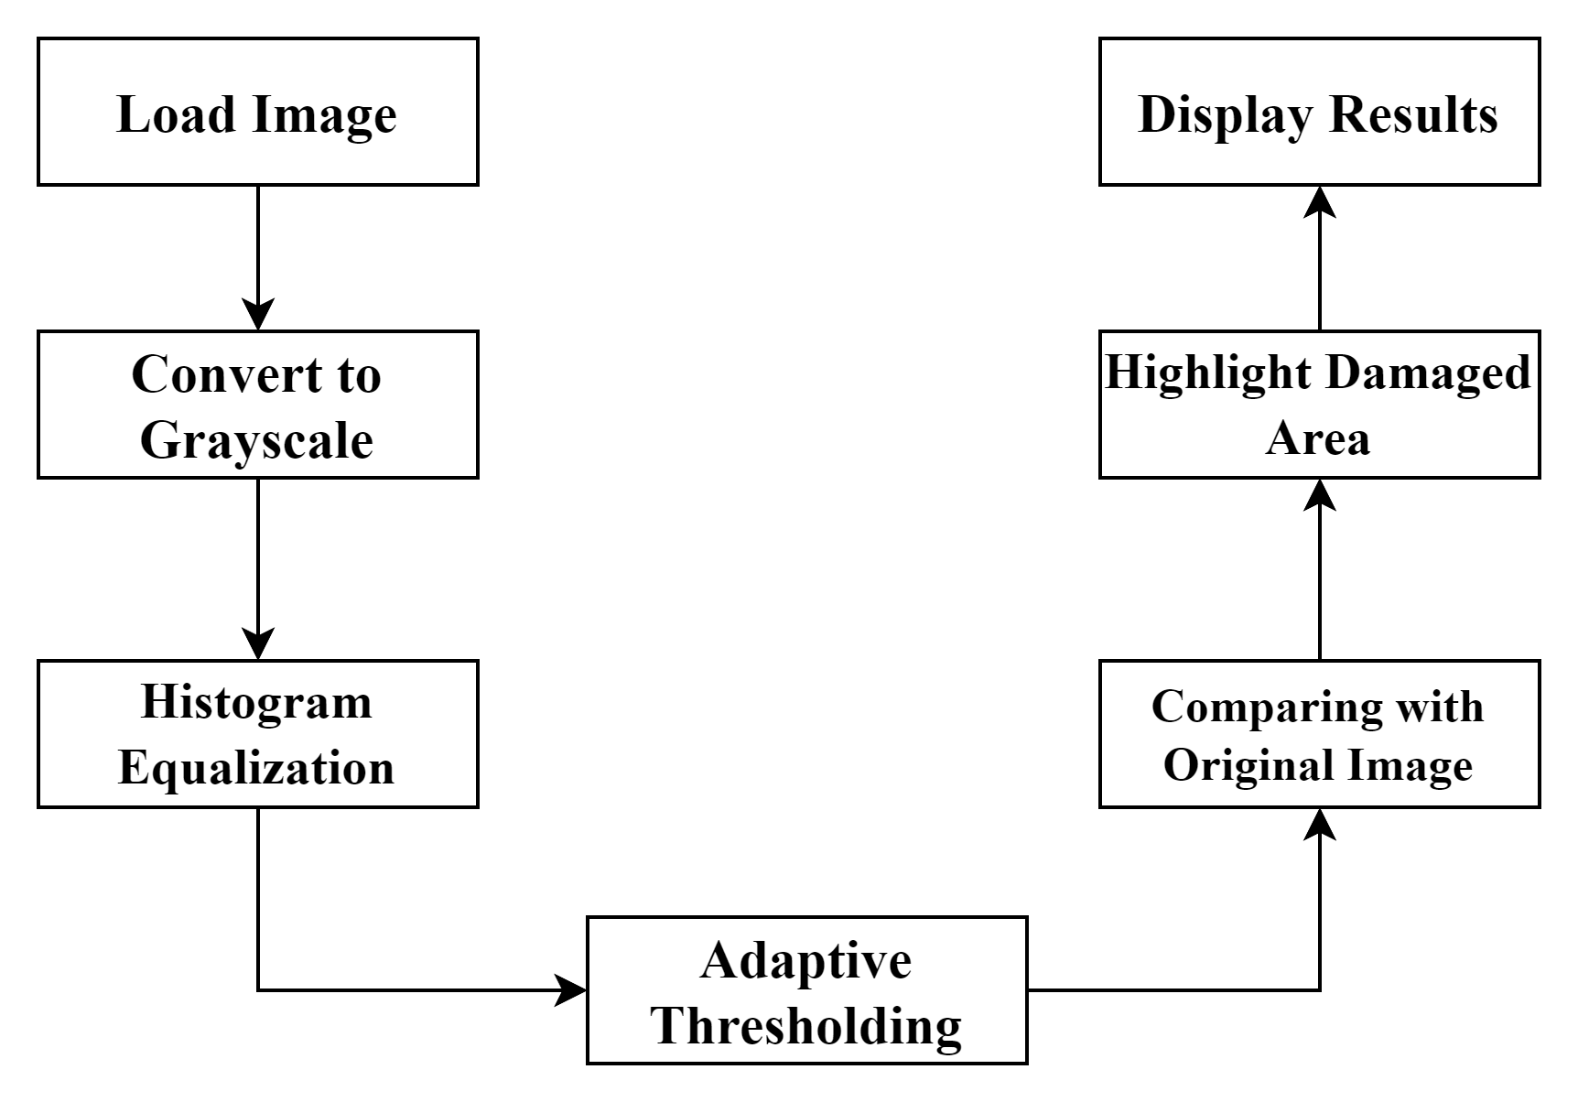

**Fig-1: Methodology while working with fundus images**

* **Load Image:**

The code loads an OCT image of the eye in grayscale using OpenCV.

* **Thresholding:**

A binary thresholding technique is applied to the grayscale image to segment the layers by converting pixel values above a certain threshold to white (255) and below to black (0).

* **Contour Detection:**

The binary image is used to find contours. These contours represent the boundaries of the segmented regions.

* **Identify Largest Contour:**

The code identifies the contour with the maximum area, assuming it represents the area of interest (e.g., the peak indicating the presence of fat).

* **Area Calculation:**

The area of the identified contour is calculated in pixels and then converted to square centimetres using a predefined conversion factor.

* **Visualization and Output:**

The largest contour is drawn on the original image for visualization. Both the original image and the segmented image with the highlighted contour are displayed. The area of the highlighted region is printed in square centimetres.

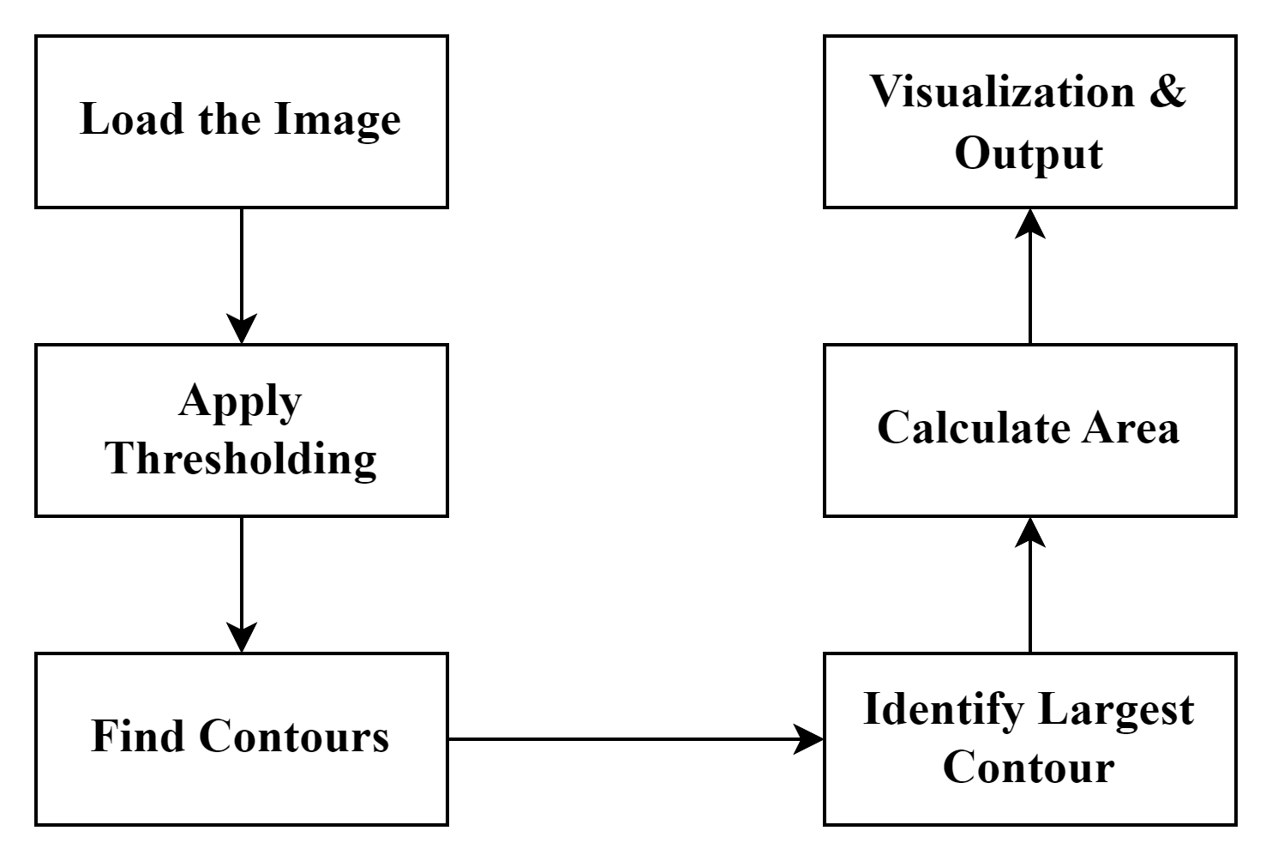

**Fig-2: Methodology while working with OCT images**

# **Experimental result and Discussion**

In this section, we showcase the outcomes of our experimental endeavors exploring Stargardt disease. Through rigorous experimentation, we provide insights into disease progression, genetic underpinnings, and potential therapeutic interventions. Here

are the outputs we got when we try to analyze and evaluate from fundus images of eye :

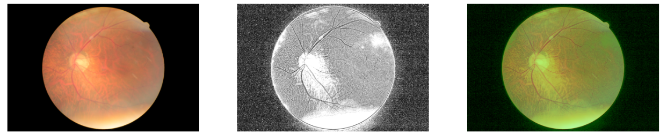

**Fig.3: Input image capturing retinal pathology**

**Fig.5: Comparing the unchanged part from black and white image with original image**

**Fig.4: Black and white image of the original image for enhanced contrast**

These are the outputs we get when we when we try to evaluate a normal and healthy fundus image of a retina. We do not find any spots or highlighted areas in the image in which we compare the black and white image with our original image.

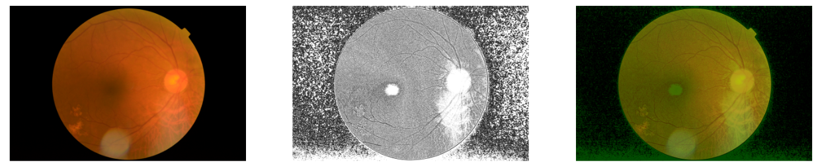

**Fig.6: Input image capturing retinal pathology**

**Fig.8: Comparing the damaged part from black and white image with original image**

**Fig.7: Black and white image of the original image for enhanced contrast**

On evaluating the fundus images of an effected eye, we can see our results. While our original image is converted into a black and white image, we are able to detect the effected or damaged area. At last, we compare the black and white image with the original image and we try find the regions which are unchanged. So, finally we highlight the damaged part and show it in the final output. This is how Stargardt’s disease is detected.

**Here are the outputs we got when we try to analyze and evaluate from OCT images of eye :**

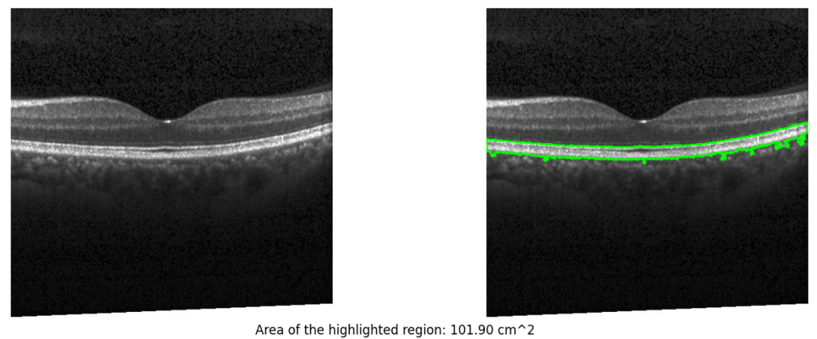

**Fig.10: Highlighting the healthy fat layer in an eye**

**Fig.9: Input image capturing retinal pathology**

These are the outputs we get when we when we try to evaluate a normal and healthy OCT image of a retina. We do not find any disturbances in the fat layer of an eye in the image and when we try to calculate the area of the fat layer we would get below 150 sq. cms. If the area is above 150 sq. cms. Then it is observed that the person is affected with the image.

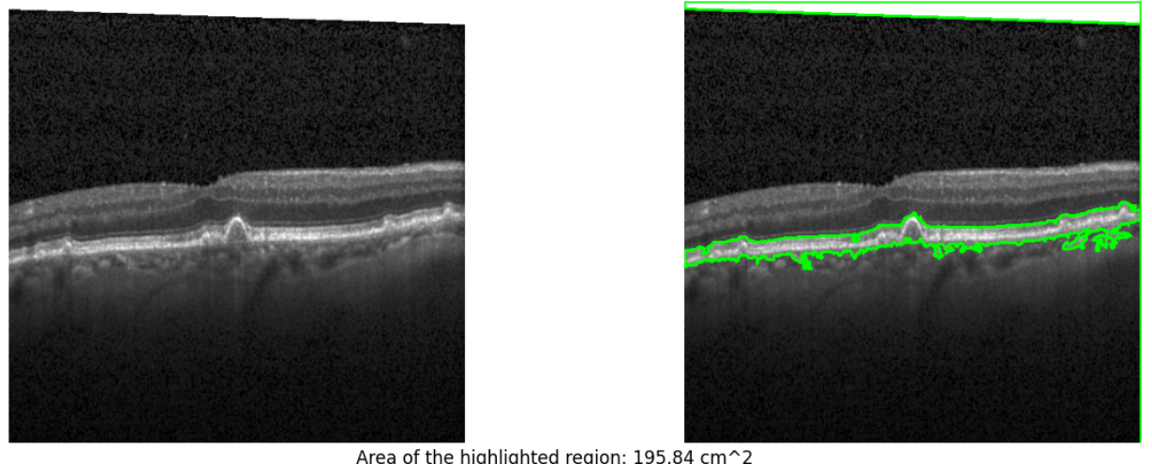

**Fig.12: Highlighting the excess fat layer in an eye**

**Fig.11: Input image capturing retinal pathology**

The output of the proposed method includes both visual and quantitative analyses of the OCT images. The visual output consists of the original OCT image with the largest detected contour highlighted in green, indicating the region of interest (ROI).

Additionally, the method calculates the area of this highlighted region and converts it into square centimeters. This quantitative measure provides a meaningful metric for further clinical assessment and comparison. The highlighted region is also saved as a separate image for detailed examination.

# **Conclusion and Future directions**

In conclusion, our project provided valuable information on the detection and analysis of Stargardt disease, shedding light on key aspects of its pathogenesis, diagnostic methods and possible therapeutic interventions. In the future, our project will open several avenues for further research and discussion. First, continued investigation of the genetic basis of Stargardt disease is essential to identify new disease-causing mutations and elucidate their functional consequences on retinal physiology. In addition, improvements in imaging techniques and the integration of artificial intelligence algorithms promise to improve the diagnostic accuracy and disease monitoring of Stargardt disease. By leveraging advances in imaging technology such as high-resolution OCT and adaptive optics, we can improve our ability to detect subtle retinal changes and track the progression of disease over time.

Finally, interdisciplinary collaboration, including ophthalmology, genetics, imaging and bioinformatics, is essential to advancing the field of Stargardt disease research. In conclusion, our project is a springboard for a deeper understanding of Stargardt disease and emphasizes the importance of continued research and innovation to address the clinical challenges of this complex retinal disease.

**References and Footnotes**

References

[1] Stargardt K. Über familiäre, progressive degeneration in der maculagegend des Auges. Graefes Arch Clin Exp Ophthalmol. 1909;(71):534e550.

[2] Allikmets R, Singh N, Sun H, et al. A photoreceptor cellspecific ATP-binding transporter gene (ABCR) is mutated in recessive Stargardt macular dystrophy. Nat Genet. 1997;15(3): 236e246.

[3] Klevering BJ, Deutman AF, Maugeri A, et al. The spectrum of retinal phenotypes caused by mutations in the ABCA4 gene. Graefes Arch Clin Exp Ophthalmol. 2005;243(2): 90e100.

[4] Lambertus S, van Huet RA, Bax NM, et al. Early-onset Stargardt disease: phenotypic and genotypic characteristics. Ophthalmology. 2015;122(2):335e344.

[5] Sangermano R, Khan M, Cornelis SS, et al. ABCA4 midigenes reveal the full splice spectrum of all reported noncanonical splice site variants in Stargardt disease. Genome Res. 2018;28(1):100e110.

[6] Cornelis SS, Runhart EH, Bauwens M, et al. Personalized genetic counseling for Stargardt disease: offspring risk estimates based on variant severity. Am J Hum Genet. 2022;109(3):498e507.

[7] Cremers FP, van de Pol DJ, van Driel M, et al. Autosomal recessive retinitis pigmentosa and cone-rod dystrophy caused by splice site mutations in the Stargardt’s disease gene ABCR. Hum Mol Genet. 1998;7(3):355e362.

[8] Runhart EH, Sangermano R, Cornelis SS, et al. The common ABCA4 variant p.Asn1868Ile shows nonpenetrance and Ophthalmology Volume 131, Number 1, January 2024 96 variable expression of Stargardt disease when present in trans with severe variants. Invest Ophthalmol Vis Sci. 2018;59(8): 3220e3231.

[9] Westeneng-van Haaften SC, Boon CJ, Cremers FP, et al. Clinical and genetic characteristics of late-onset Stargardt’s disease. Ophthalmology. 2012;119(6):1199e1210.

[10] Lambertus S, Lindner M, Bax NM, et al. Progression of lateonset Stargardt disease. Invest Ophthalmol Vis Sci. 2016;57(13):5186e5191.

[11]. van Huet RA, Bax NM, Westeneng-Van Haaften SC, et al. Foveal sparing in Stargardt disease. Invest Ophthalmol Vis Sci. 2014;55(11):7467e7478.

[12] Runhart EH, Dhooge P, Meester-Smoor M, et al. Stargardt disease: monitoring incidence and diagnostic trends in The Netherlands using a nationwide disease registry. Acta Ophthalmol. 2022;100(4):395e402.

[13] Bauwens M, Garanto A, Sangermano R, et al. ABCA4- associated disease as a model for missing heritability in autosomal recessive disorders: novel noncoding splice, cisregulatory, structural, and recurrent hypomorphic variants. Genet Med. 2019;21(8):1761e1771.

[14] Khan M, Cornelis SS, Pozo-Valero MD, et al. Resolving the dark matter of ABCA4 for 1054 Stargardt disease probands through integrated genomics and transcriptomics. Genet Med. 2020;22(7):1235e1246.

[15] Zernant J, Lee W, Collison FT, et al. Frequent hypomorphic alleles account for a significant fraction of ABCA4 disease and distinguish it from age-related macular degeneration. J Med Genet. 2017;54(6):404e412